Fitness Tracker — Design Phase
Decomposition, Algorithm Design and Iterative Testing
This document continues the Design Module section of the main NEA report (Fitness Tracker.docx), which ends at the module breakdown and Hierarchy Diagram. It covers criterion (c) — describing the solution fully using accurate algorithms and justifying how they form a complete solution — and criterion (f) — identifying and justifying the test data used during iterative development. Flowcharts are reproductions of the pages already drawn in docs/flowcharts.drawio; pseudocode is written directly from the actual Reflex state-class code in fitness_tracker/fitness_tracker/.
Screenshot placeholders are left throughout Section 3 — paste evidence captured from the running app (GUI) into each one.

1. Decomposition
The Design Module section of the main report breaks the system into eight modules (User Management, Fitness Management, Goal Management, Progress Management, Database Management, Notification System, Input Validation and User Interface). Each module is only simple enough to design, code and test once it is broken down further into the individual algorithms that implement its main functions. The table below lists the algorithm covered for each module in Section 2 of this document.
Algorithm | Module(s) | Purpose
Account Login | User Management | Authenticate a returning user and start their session.
Account Registration | User Management | Create a new, unique user account and log them straight in.
Add / Edit Fitness Data | Fitness Management, Input Validation | Validate and store a new workout, weight, calorie or step entry.
Set a Fitness Goal | Goal Management, Input Validation | Validate and save a personal target for one metric.
Calculate Progress & Generate Dashboard | Progress Management, Notification System | Compare today's totals against each goal and build the trend charts.
View / Search History | Progress Management | Retrieve and format a user's full record history.
Edit Account Settings | User Management, Input Validation | Validate and update the logged-in user's profile.

Breaking the Design Module down to this level is justified because every algorithm above maps to exactly one user-facing action (one button click or one page load), so each can be designed, coded and tested in isolation before being combined — e.g. Account Login can be fully tested without Fitness Management existing yet, since it only depends on the User table. Section 2 gives each algorithm as a flowchart (reproduced from docs/flowcharts.drawio) and matching pseudocode, together with a justification and an explanation of how it connects to the others; Section 3 then documents the iterative testing carried out against each one.

2. Algorithm Design
Each algorithm below is given as a flowchart and as pseudocode, so it is detailed enough to code directly from — in fact each one already matches the real implementation in the fitness_tracker Reflex app, referenced under each pseudocode block.

2.1 Account Login

Flowchart
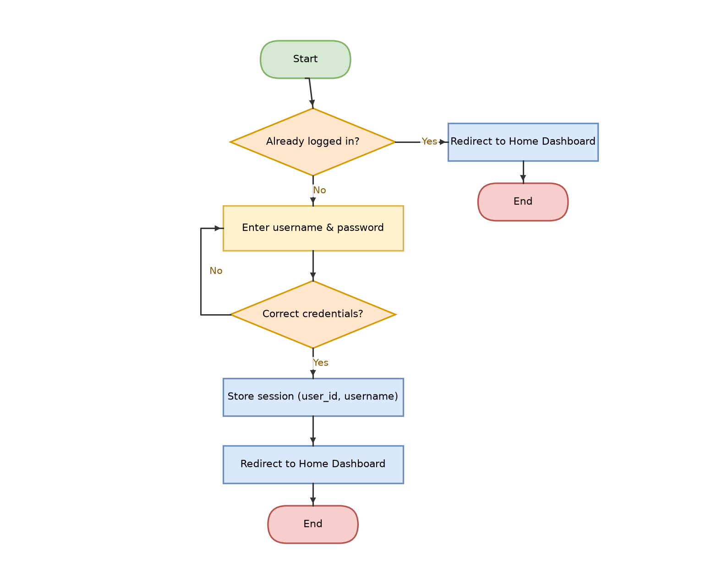
Figure 2.1: Account Login flowchart (docs/flowcharts.drawio, page “3. Login Page”).

Pseudocode
BEGIN AccountLogin
ON page load:
IF user already logged in THEN
REDIRECT TO Home Dashboard
STOP
ENDIF

ON click “Log In”:
error ← “”
INPUT username, password
TRY
user ← SELECT * FROM User WHERE username = username
IF user NOT FOUND OR NOT VERIFY(password, user.password_hash) THEN
RAISE InvalidCredentialsError(“Incorrect username or password.”)
ENDIF
CATCH InvalidCredentialsError AS e
error ← e.message
DISPLAY error
STOP
END TRY
session.user_id ← user.user_id
session.username ← user.username
CLEAR password from memory
REDIRECT TO Home Dashboard
END

FUNCTION VERIFY(password, stored)
salt, storedHash ← SPLIT(stored, “$”)
computedHash ← PBKDF2_HMAC_SHA256(password, salt, 100 000 rounds)
RETURN computedHash = storedHash
END FUNCTION

Justification
The same generic error is shown whether the username does not exist or the password is wrong, so a failed attempt cannot be used to guess valid usernames. Passwords are never stored or compared in plain text — a random salt plus 100,000 rounds of PBKDF2-HMAC-SHA256 (see login_state.py and db.py) is deliberately slow, making a stolen database of hashes much harder to brute-force. This satisfies the security requirement identified during analysis: each user's fitness data must only be visible to them.

How This Algorithm Connects to the Others
Login is the entry point every other module depends on: the session.user_id it stores is what Fitness Management, Goal Management, Progress Management, History and Account Settings all use to filter the database to just the current user. Account Registration leads into this algorithm's success path directly (a new account logs the user in immediately, rather than sending them back to a separate login step).

2.2 Account Registration

Flowchart
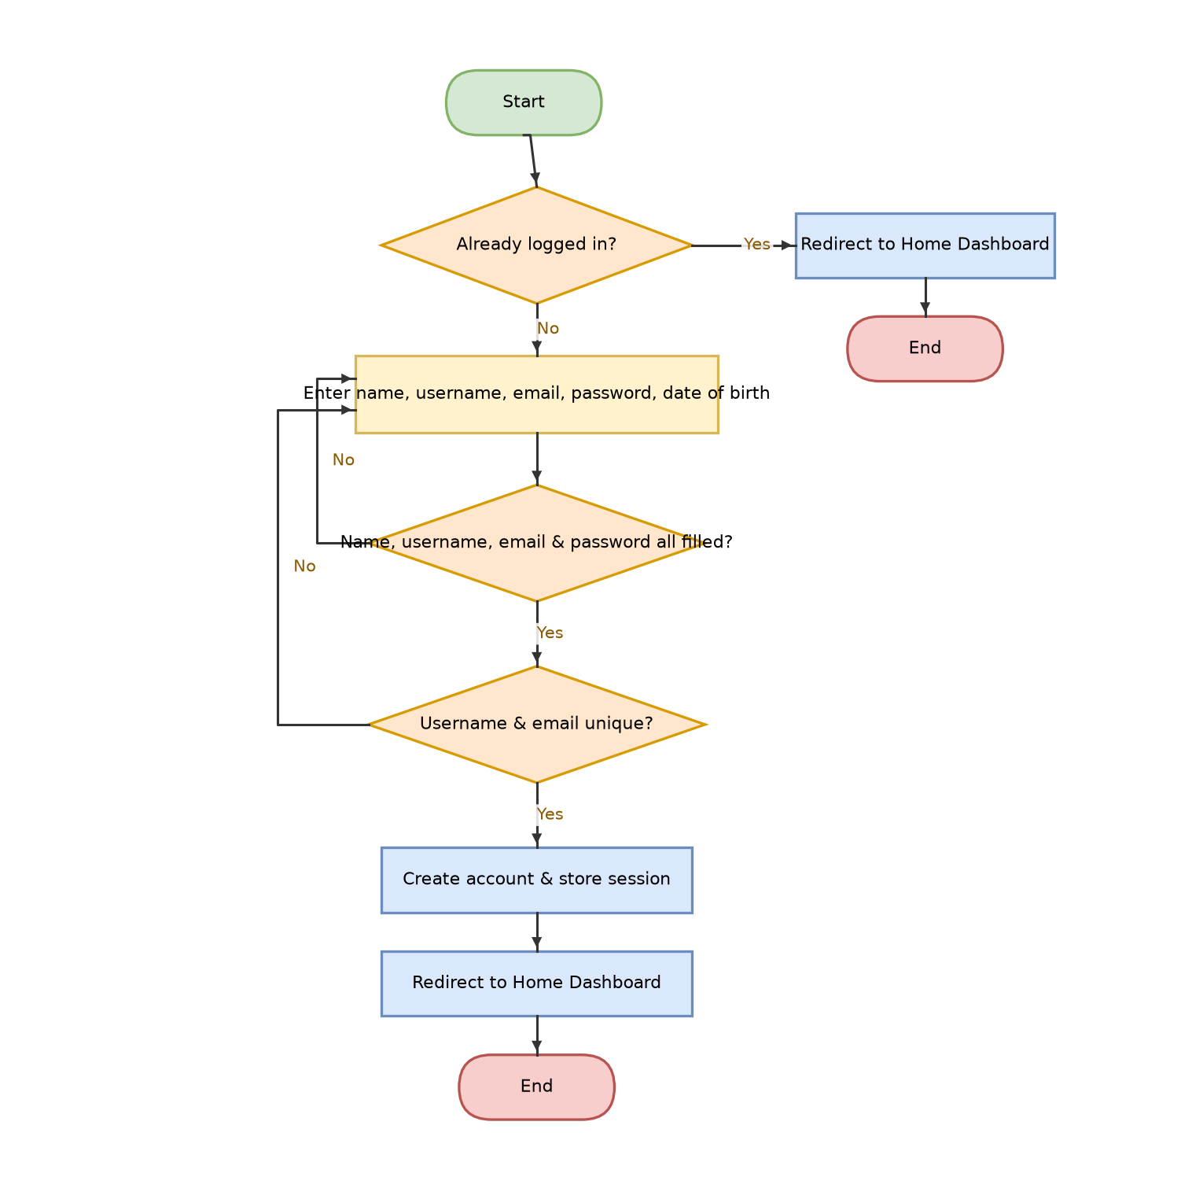
Figure 2.2: Account Registration flowchart (docs/flowcharts.drawio, page “4. Register Page”).

Pseudocode
BEGIN AccountRegistration
ON page load:
IF already logged in THEN REDIRECT TO Home Dashboard; STOP

ON click “Register”:
error ← “”
INPUT name, username, email, password, date_of_birth
IF NOT (name AND username AND email AND password) THEN
error ← “Please fill in name, username, email and password.”
STOP
ENDIF
TRY
new_id ← INSERT INTO User(username, HASH(password), email,
name, date_of_birth)
CATCH DuplicateUserError AS e // UNIQUE(username), UNIQUE(email)
error ← e.message
STOP
END TRY
session.user_id ← new_id
session.username ← username
CLEAR password from memory
REDIRECT TO Home Dashboard
END

Justification
Checking that all four required fields are filled in before touching the database avoids an unnecessary database call for an input that is obviously incomplete. Uniqueness of username and email is enforced by the database's own UNIQUE constraints rather than a separate “search first” query — this is both faster (SQLite indexes the constraint) and safer (no race condition between checking and inserting).

How This Algorithm Connects to the Others
This is the only algorithm that creates a new User row, so every other module's data (workouts, goals, notifications, etc.) ultimately depends on a row this algorithm produced. Its success path re-uses Account Login's session-storage step so the user does not have to log in twice.

2.3 Add / Edit Fitness Data

Flowchart
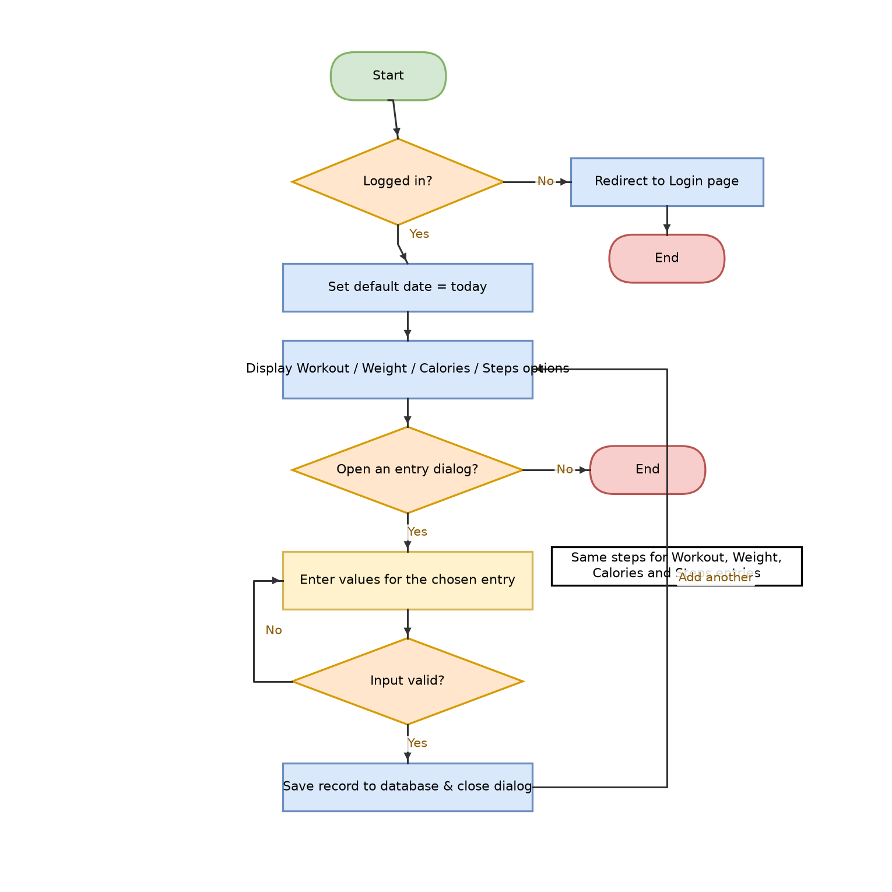
Figure 2.3: Add / Edit Fitness Data flowchart (docs/flowcharts.drawio, page “7. Add Fitness Data”).

Pseudocode
BEGIN AddFitnessData (example: Weight; the same pattern is used for
Workout, Calories and Steps — see note below)
ON page load:
IF NOT logged in THEN REDIRECT TO Login; STOP
SET each dialog's date field to today's date

ON click “Save” in the Weight dialog:
message ← “”
IF weight_value is empty OR date is empty THEN
message ← “Fill in weight and date.”
STOP
ENDIF
TRY
weight ← TO_NUMBER(weight_value)
CATCH ValueError
message ← “Weight must be a number.”
STOP
END TRY
IF weight ≤ 0 THEN
message ← “Weight must be a positive number.”
STOP
ENDIF
INSERT INTO WeightRecord(user_id, weight, date)
CLEAR the form, CLOSE the dialog
END

// Workout: duration must be a whole number > 0.
// Calories: consumed and/or burned must each be a whole number ≥ 0,
// and at least one of the two must be provided.
// Steps: step_count must be a whole number ≥ 0.

Justification
Type checking (TO_NUMBER) stops text such as “abc” being stored where a number is expected, and the positive/non-negative checks stop physically impossible values (e.g. –10 kg, −500 steps) from corrupting later calculations — this directly implements Design Module requirement 3.1 (“negative values can't be entered”). Section 3.1 of this document records how this check was added after iterative testing showed it was missing.

How This Algorithm Connects to the Others
Every successful save here is read back by Progress Management (today's totals on the Home Dashboard), History (the full record list) and, for steps/workouts/calories, by Goal Management when comparing progress against a target. Input Validation is shared with Registration and Account Settings, which apply the same “type-check then range-check” pattern to their own fields.

2.4 Set a Fitness Goal

Flowchart
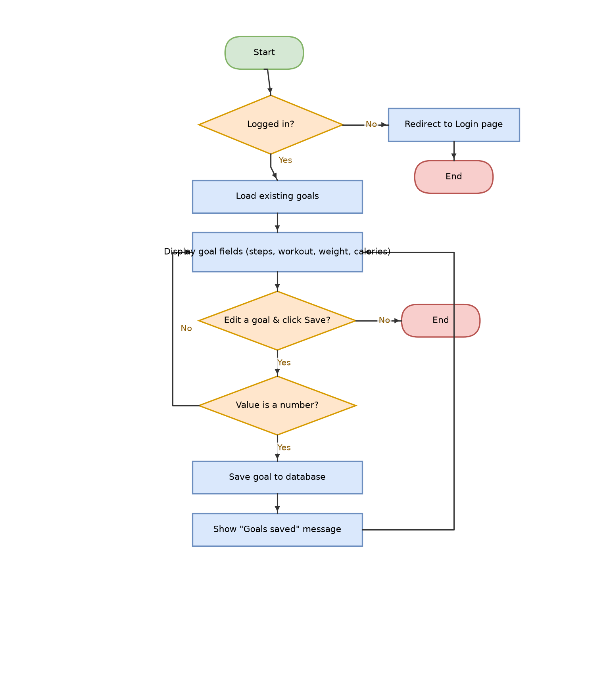
Figure 2.4: Set a Fitness Goal flowchart (docs/flowcharts.drawio, page “8. Fitness Goals”).

Pseudocode
BEGIN SetFitnessGoal (example: Steps Goal; Workout Duration, Weight
and Calories goals follow the same pattern)
ON page load:
IF NOT logged in THEN REDIRECT TO Login; STOP
FOR EACH goal_type the user already has a Goal row for:
PRE-FILL that field with its target_value

ON click “Save” next to Steps Goal:
message ← “”
TRY
target ← TO_NUMBER(steps_goal_input)
CATCH ValueError
message ← “Steps goal must be a number.”
STOP
END TRY
IF target ≤ 0 THEN
message ← “Steps goal must be a positive number.”
STOP
ENDIF
UPSERT Goal(user_id, “steps”, target, start_date = today)
// INSERT if this is the user's first steps goal,
// otherwise UPDATE the existing row (UNIQUE(user_id, goal_type))
message ← “Goals saved.”
END

Justification
A goal of zero or a negative target is meaningless and would make the later progress-percentage calculation divide by zero or produce a negative percentage, so it is rejected at the point of entry rather than handled defensively everywhere it is later read. UPSERT (INSERT … ON CONFLICT DO UPDATE) keeps exactly one current goal per type instead of letting duplicates build up, since a goal is a target, not a history.

How This Algorithm Connects to the Others
This algorithm supplies the target_value that Progress Calculation compares each day's totals (produced by Add Fitness Data) against, and that target also feeds the Notification System's “goal achieved” message and the goal column shown on the History page's step table.

2.5 Calculate Progress & Generate Dashboard

Flowchart
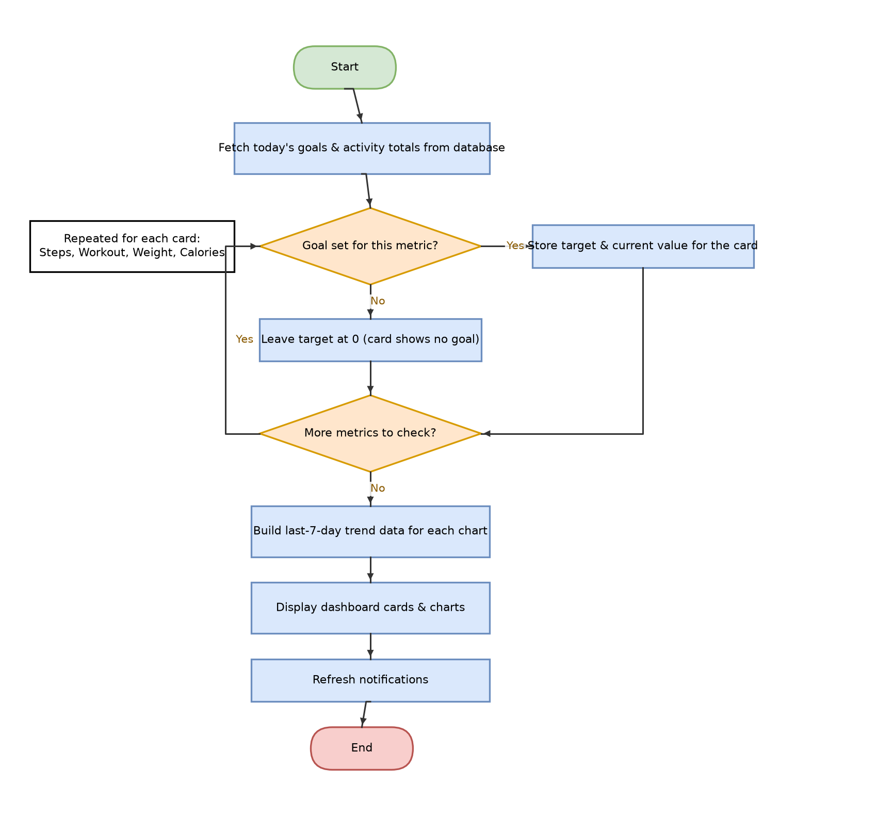
Figure 2.5: Calculate Progress & Generate Dashboard flowchart (docs/flowcharts.drawio, page “6. Dashboard (Progress Cards)”).

Pseudocode
BEGIN CalculateProgressAndGenerateDashboard
IF NOT logged in THEN REDIRECT TO Login; STOP
goals ← SELECT * FROM Goal WHERE user_id = current_user
totals ← SUM of today's StepRecord / WorkoutRecord / CalorieRecord
rows WHERE user_id = current_user AND date = today

FOR EACH metric IN {Steps, Workout, Weight, Calories}
IF metric NOT IN goals THEN
target[metric] ← 0 // card shows “no goal set”
ELSE
target[metric] ← goals[metric].target_value
current[metric] ← totals[metric] // or latest weight, for Weight
ENDIF
NEXT metric

FOR EACH chart IN {Weight, Steps, Workout, Calories}
series[chart] ← last 7–14 days of that metric,
filling any day with no data as 0
NEXT chart

DISPLAY progress cards (target vs current) and trend charts
REFRESH notifications (see Notification System, below)
END

// Notification System (called above):
IF user has logged nothing today AND no reminder sent today THEN
INSERT INTO Notification(user_id, “activity_reminder”, message)
ENDIF

Justification
Missing days are filled in as 0 rather than skipped so every chart's x-axis always spans a full, consistent date range — a gap-filled chart is far easier to read at a glance than one with irregular spacing. Checking “has anything been logged today” before creating a reminder (and never creating a second reminder for the same day) stops the same notification appearing every time a page loads.

How This Algorithm Connects to the Others
This is the algorithm that turns raw rows from Add Fitness Data into the information the user actually wants (“am I on track?”), using targets set by Set a Fitness Goal. It is also what triggers the Notification System, and its per-metric loop is the same structure used by View / Search History to build its four tables.

2.6 View / Search History

Flowchart
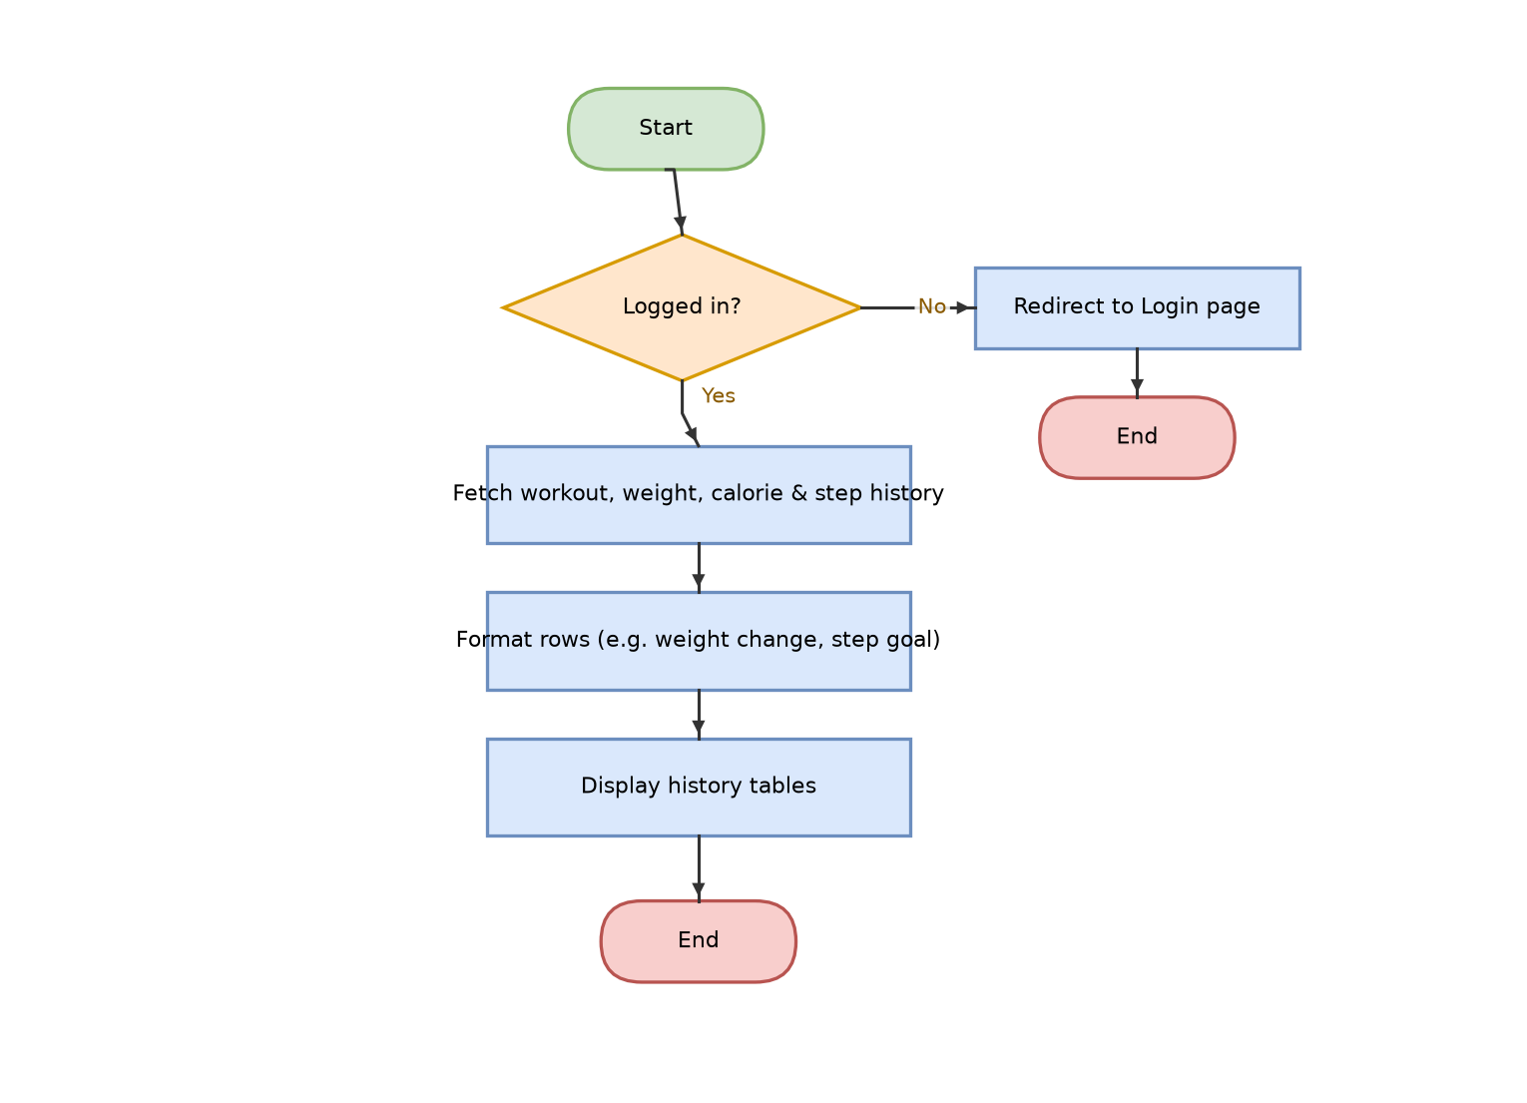
Figure 2.6: View / Search History flowchart (docs/flowcharts.drawio, page “9. History”).

Pseudocode
BEGIN ViewHistory
IF NOT logged in THEN REDIRECT TO Login; STOP

workouts ← SELECT date, workout_type, duration_minutes
FROM WorkoutRecord WHERE user_id = current_user
ORDER BY date DESC

weights ← SELECT date, weight_kg FROM WeightRecord
WHERE user_id = current_user ORDER BY date DESC
FOR i ← 0 TO LENGTH(weights) − 1
IF i + 1 < LENGTH(weights) THEN
change[i] ← weights[i].weight_kg − weights[i+1].weight_kg
ELSE
change[i] ← “–” // oldest entry: nothing earlier to compare
ENDIF
NEXT i

calories ← SELECT date, calories_consumed, calories_burned
FROM CalorieRecord WHERE user_id = current_user
ORDER BY date DESC

steps_goal ← SELECT target_value FROM Goal
WHERE user_id = current_user AND goal_type = “steps”
steps ← SELECT date, step_count FROM StepRecord
WHERE user_id = current_user ORDER BY date DESC

DISPLAY four tables: workouts, weights (+ change),
calories, steps (+ steps_goal)
END

Justification
Ordering every query newest-first means the most relevant (most recent) entries are visible immediately without the user having to scroll or search, which matches the analysis finding that users currently rely on unreliable memory or notes to track patterns. Showing the change since the previous weight entry, rather than just a raw list of numbers, turns stored data into information the user can act on.

How This Algorithm Connects to the Others
History only reads data — it depends on every record created by Add / Edit Fitness Data and every goal created by Set a Fitness Goal, but nothing else in the system depends on it. It is the last stage in each module's data flow.

2.7 Edit Account Settings

Flowchart
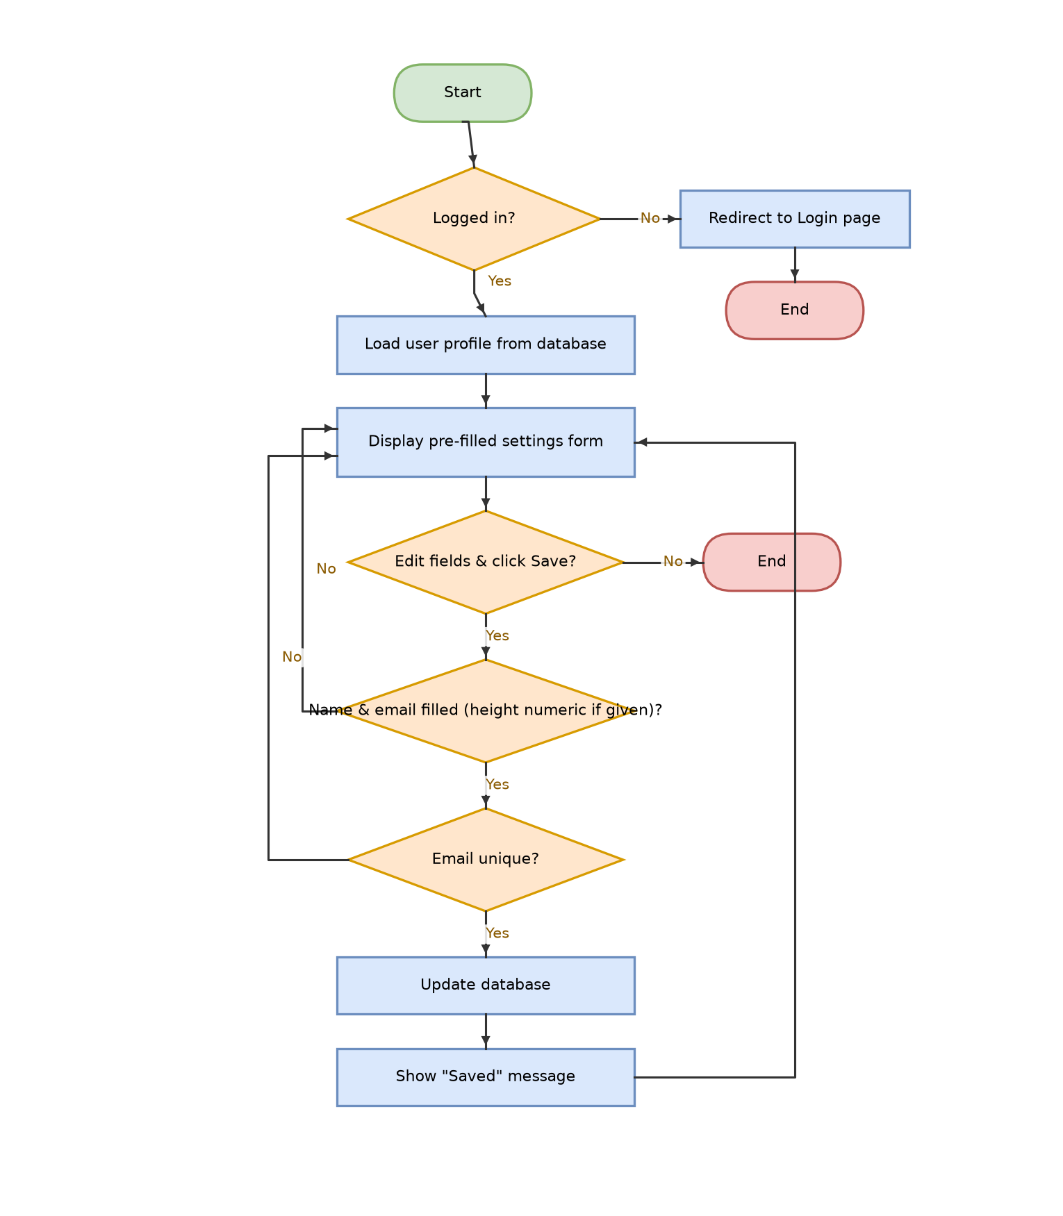
Figure 2.7: Edit Account Settings flowchart (docs/flowcharts.drawio, page “10. Account Settings”).

Pseudocode
BEGIN EditAccountSettings
ON page load:
IF NOT logged in THEN REDIRECT TO Login; STOP
user ← SELECT * FROM User WHERE user_id = current_user
PRE-FILL form WITH user.name, email, gender, height_cm,
date_of_birth

ON click “Save”:
error ← “”
IF name is empty OR email is empty THEN
error ← “Name and email are required.”
STOP
ENDIF
IF height_cm was provided THEN
TRY
height ← TO_NUMBER(height_cm)
CATCH ValueError
error ← “Height must be a number.”
STOP
END TRY
IF height ≤ 0 THEN
error ← “Height must be a positive number.”
STOP
ENDIF
ENDIF
TRY
UPDATE User SET name, email, gender, height, date_of_birth
WHERE user_id = current_user
CATCH DuplicateUserError // email UNIQUE constraint
error ← “That email is already registered.”
STOP
END TRY
message ← “Saved.”
END

Justification
Re-applying the same type-check and positive-number rule used in Add Fitness Data (rather than trusting that only sensible values can reach this point) means a user cannot end up with, for example, a height of −80 cm just because this form was reached by a different route than Registration. Re-using the database's own UNIQUE(email) constraint again avoids a separate duplicate-checking query.

How This Algorithm Connects to the Others
This algorithm edits the same User row that Account Registration created and Account Login authenticates against, so a validation rule added here keeps that row consistent with the rules already enforced when the account was first created.

3. Iterative Testing
Each algorithm above was tested with normal, boundary and erroneous test data — the three categories needed to show a test plan is thorough: normal data that should be accepted, boundary data at the edge of what is valid, and erroneous data that should be rejected with a clear error message rather than crashing or corrupting the database. Testing is iterative: where a test exposed a gap between the design (Section 2, and the Design Module requirements in the main report) and the actual code, the code was corrected and the test re-run to confirm the fix, instead of just noting the failure.

3.1 Bug Found During Testing: Negative Values Were Accepted
Design Module requirement 3.1 in the main report states that “negative values can't be entered” for numeric fitness data. Testing Add Fitness Data, Set a Fitness Goal and Edit Account Settings with boundary/erroneous data such as “−10” for weight showed this was not actually enforced: the code checked that a value was a number, but not that it was positive, so −10 kg, a −30-minute workout or a −100-step goal were all silently accepted and written to the database. This is exactly the kind of gap iterative testing is meant to catch before the final solution is evaluated. The fix below adds an explicit range check immediately after the existing type check, in every handler that saves a numeric value (shown here for save_weight() in add_fitness_data_state.py; the same two-line pattern was added to save_workout(), save_calories(), save_steps(), all four Set a Fitness Goal handlers, and the height field in Edit Account Settings).
def save_weight(self):
self.weight_message = ""
if not (self.weight_value and self.weight_date):
self.weight_message = "Fill in weight and date."
return
try:
weight = float(self.weight_value)
except ValueError:
self.weight_message = "Weight must be a number."
return
+ if weight <= 0:
+ self.weight_message = "Weight must be a positive number."
+ return
db.add_weight_record(self.user_id, weight, self.weight_date)

After adding this check to all nine handlers, the negative-value test cases in the tables below were re-run and confirmed as Pass.

3.2 Test Data and Results

3.2.1 Account Login
Module | Test Case | Test Data | Expected Outcome | Actual Outcome | Pass/Fail
Login | Normal: correct username & password | john123 / CorrectPass1 | Session started; redirected to Home Dashboard. | As expected — logged in and redirected. | Pass
Login | Erroneous: wrong password | john123 / WrongPass | “Incorrect username or password.” shown; not logged in. | Error shown as expected. | Pass
Login | Erroneous: username does not exist | nosuchuser / anything | Same generic “Incorrect username or password.” message (does not reveal the username is invalid). | Same generic message shown. | Pass
Login | Boundary/security: SQL-injection-style input | ' OR '1'='1 | Treated as a literal username that doesn't match any row; access denied. | Access denied — parameterised queries in db.py ("?" placeholders) mean the string is never treated as SQL. | Pass

[ Screenshot placeholder — paste evidence of the running app for “Account Login” here ]

3.2.2 Account Registration
Module | Test Case | Test Data | Expected Outcome | Actual Outcome | Pass/Fail
Register | Normal: all fields completed | name=Jo, user=jo99, email=jo@x.com, pass=Secret1 | Account created; logged in; redirected to Home Dashboard. | Account created as expected. | Pass
Register | Erroneous: required field left blank | password left blank | “Please fill in name, username, email and password.” shown; no account created. | Error shown as expected. | Pass
Register | Erroneous: username already taken | user=jo99 (duplicate) | “That username or email is already registered.” shown. | Error shown as expected. | Pass

[ Screenshot placeholder — paste evidence of the running app for “Account Registration” here ]

3.2.3 Add / Edit Fitness Data
Module | Test Case | Test Data | Expected Outcome | Actual Outcome | Pass/Fail
Fitness Data | Normal: valid weight entry | weight=70.5, date=today | Record saved; dialog closes. | Saved as expected. | Pass
Fitness Data | Erroneous: non-numeric weight | weight="abc" | “Weight must be a number.” shown; nothing saved. | Error shown as expected. | Pass
Fitness Data | Erroneous: negative weight (pre-fix) | weight=-10 | Rejected — Design Module 3.1 requires negative values to be blocked. | No check existed yet — record saved with weight = −10. | Fail
Fitness Data | Erroneous: negative weight (post-fix, retested) | weight=-10 | “Weight must be a positive number.” shown; nothing saved. | Error shown; record not saved — see fix in Section 3.1. | Pass
Fitness Data | Boundary: zero steps | steps=0 | Accepted (0 is a valid — if unlikely — day's step count). | Saved as expected. | Pass
Fitness Data | Erroneous: non-numeric duration | duration="thirty" | “Duration must be a whole number.” shown. | Error shown as expected. | Pass

[ Screenshot placeholder — paste evidence of the running app for “Add / Edit Fitness Data” here ]

3.2.4 Set a Fitness Goal
Module | Test Case | Test Data | Expected Outcome | Actual Outcome | Pass/Fail
Goals | Normal: valid steps goal | steps_goal=10000 | “Goals saved.” shown; goal stored. | Saved as expected. | Pass
Goals | Erroneous: negative goal (pre-fix) | steps_goal=-100 | Rejected — a negative target is meaningless. | No check existed yet — goal saved as −100. | Fail
Goals | Erroneous: negative goal (post-fix, retested) | steps_goal=-100 | “Steps goal must be a positive number.” shown; not saved. | Error shown; not saved — see fix in Section 3.1. | Pass
Goals | Erroneous: non-numeric goal | weight_goal="heavy" | “Weight goal must be a number.” shown. | Error shown as expected. | Pass

[ Screenshot placeholder — paste evidence of the running app for “Set a Fitness Goal” here ]

3.2.5 Calculate Progress & Generate Dashboard
Module | Test Case | Test Data | Expected Outcome | Actual Outcome | Pass/Fail
Progress | Normal: goal set, some progress logged | steps_goal=10000, steps_today=6000 | Card shows 6,000 / 10,000 (60%). | Displayed as expected. | Pass
Progress | Boundary: no goal set for a metric | no calories goal set | Card shows “no goal set” instead of a percentage (target defaults to 0). | Displayed as expected. | Pass
Progress | Boundary: goal exceeded | steps_goal=10000, steps_today=14000 | Progress shown as 100%+/complete, not an error. | Displayed as expected. | Pass
Progress | Boundary: no activity logged today | no records for today | Totals show 0; a daily activity reminder notification is created (once only). | Reminder created as expected; not duplicated on refresh. | Pass

[ Screenshot placeholder — paste evidence of the running app for “Calculate Progress & Generate Dashboard” here ]

3.2.6 View / Search History
Module | Test Case | Test Data | Expected Outcome | Actual Outcome | Pass/Fail
History | Normal: multiple records exist | 3 weight entries logged | All 3 rows shown, newest first, with weight change vs previous entry. | Displayed as expected. | Pass
History | Boundary: no records logged yet | new account, no data | Table displays empty rather than an error. | Displayed as expected. | Pass
History | Boundary: oldest weight entry | first-ever weight record | Change column shows “–” (nothing earlier to compare to). | Displayed as expected. | Pass

[ Screenshot placeholder — paste evidence of the running app for “View / Search History” here ]

3.2.7 Edit Account Settings
Module | Test Case | Test Data | Expected Outcome | Actual Outcome | Pass/Fail
Account Settings | Normal: valid update | name=Jo Smith, email=jo@x.com | “Saved.” shown; profile updated. | Saved as expected. | Pass
Account Settings | Erroneous: email already used by another account | email=taken@x.com | “That email is already registered.” shown; not saved. | Error shown as expected. | Pass
Account Settings | Erroneous: negative height (pre-fix) | height=-80 | Rejected — a negative height is impossible. | No check existed yet — saved as −80. | Fail
Account Settings | Erroneous: negative height (post-fix, retested) | height=-80 | “Height must be a positive number.” shown; not saved. | Error shown; not saved — see fix in Section 3.1. | Pass

[ Screenshot placeholder — paste evidence of the running app for “Edit Account Settings” here ]

